Intersymbol Interference (ISI) and Equalization

Park, Jee Hyun

School of Electrical and Electronic Engineering

SungKyunKwan University

Seoul, Republic of Korea

jhyun19@gmail.com

*Abstract*—We will take a look of Intersymbol Interference (ISI) and try to understand what it is and why it happened. And then we will discuss about the method to eliminate the effect of ISI. There are two ways, one is satisfying Nyquist condition and the other is equalization. Lastly, we will introduce a method, called zero-forcing equalizer, to reduce ISI component and explain how does it work.

Keywords---Equalization; Intersymbol Interference(ISI); Nyquist Condition;

# Intersymbol Interference

To describe and understand the meaning of intersymbol interference (ISI), let assume that we are transmitting a stream of symbols with the basic waveform *u(t)*. Transmitting the n-th symbol from sender to receiver through a channel, we can compute the output *bnu(t-nT),* where T stands for the interval between adjacent two symbols. Therefore, the transmitted signal is

$$\sum_{n}^{∞}{b_{n}u(t-nT)} . (2.1)$$

According to the dispersive channel model, we can compute the received signal as

$$Received Signal : \\ r\left(t\right)= \sum_{n}^{∞}{b_{n}v\left(t-nT\right)+n\left(t\right) , (2.2)}$$

$$Received waveform :v\left(t\right)= u*h_{c}\left(t\right) ,$$

$$AWGN with PSD\frac{N_{0}}{2} :n\left(t\right) .$$

If we input a single symbol to the system, we can pass the received signal through the matched filter. Then we can sample the matched filter output to get the decision statistic. If we input a stream of symbols to the channel, we can still use this matched filter to do demodulation. Then at time *t = mT,* we can receive the decision statistic for *bm*. So at *t = mT,* we can get the output of the matched filter that

$$z_{m}= \sum_{n}^{∞}{b_{n}v*\tilde{v}\left(mT-nT\right)+ n_{m} } (2.3)$$ $= b_{m}{\left\|v\right\|}^{2}+ \sum_{n≠m}{b_{n}v*\tilde{v}(mT-nT})+n_{m}$ (2.4)

where *nm* is a zero-mean Gaussian random variable with variance *N02/2*. The first term in expression 2.4 is the part what we want which is the signal contribution from the symbol bn, and the second term is composed of the other symbols, which are the unwanted part called intersymbol interference (ISI).

Suppose *v(t)* were time-limited signal for example v(t) = 0 if *t $∉$* [0, T]. Then we can derive that $v\left(t\right)*\tilde{v}\left(t\right)= 0$ if $t∉$ (-T, T). Therefore, $v\left(t\right)*\tilde{v}\left(mT-nT\right)=0$ for all $n≠m$, no intersymbol interference appears in the sections. It means that we are able to eliminate the second term in expression 2.4 which is the unwanted part of the output of matched filter, in other words, no ISI in this case. As a result, the demodulation method, we just mentioned above, can transmit and translate for each symbol with no error. But, a time-limited signal cannot be a band-limited signal. Therefore, for a band-limited channel, $v\left(t\right)*\tilde{v}\left(t\right)$ is not time-limited. So intersymbol interference will be appeared sine we assume that *v(t)* is time-limited signal in above. So we are having unwanted part in our received signal and it will cause errors in communication procedure. We can check the effect of the ISI with simple example. In general, to simulate and check the existence of intersymbol interference, we use *eye diagram of received signal*. Unlike the figure 1, we can see the distortion in figure 2 which will be recognized as an error. Now we are going to discuss about how to minimize or suppress of the effect of ISI.

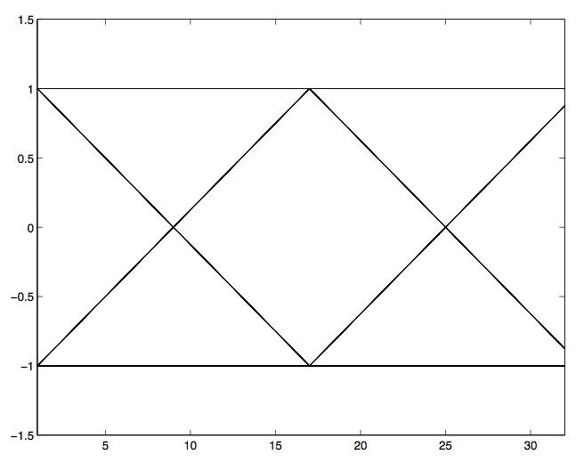

Figure 1 Eye diagram of a Binary Phase Shift Keying signal with no intersymbol interference

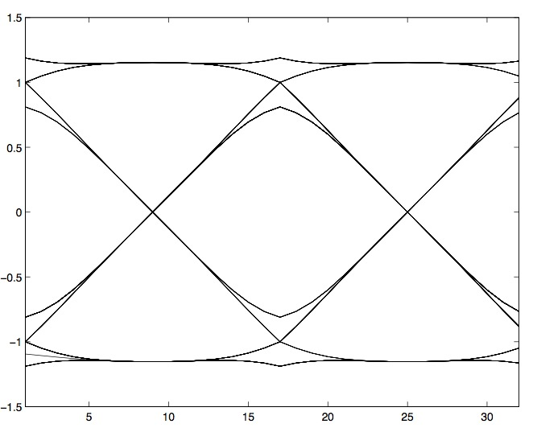

Figure 2 Eye diagram of a Binary Phase Shift Keying signal with intersymbol interference effect

# Nyquist Pulse

We can reduce, minimize or suppress the effects of ISI even if the input of the channel, *v(t),* is band-limited signal. There is a certain type of signals which have ISI-free pulses and it is called *Nyquist pulses*. To describe this type of pulses more precisely, we need to rewrite expression 2.4 with transposition $v\left(t\right)*\tilde{v}\left(t\right)$ to *x(t)* and the result is following.

$z_{m}= b_{m}x(0)+ \sum_{n≠m}{b_{n}x(mT-nT})+n_{m}$ (3.1)

The following condition is called *Nyquist condition* and if the signal is satisfied with these conditions, there will be no ISI.

$$x\left(nT\right)= \left\{\begin{aligned}c for n=0, \\ 0 for n≠0.\end{aligned} (3.2)\right.$$

To get Nyquist condition in frequency-domain, let assume sampled signal as:

$$x_{δ}\left(t\right)= \sum_{n=-∞}^{∞}{x\left(nT\right)δ\left(t-nT\right). (3.3)}$$

Taking Fourier transform, we can get following expression:

$$X_{δ}\left(f\right)= \frac{1}{T}\sum_{n=-∞}^{∞}{X\left(f-\frac{n}{T}\right) (3.4)}$$

According to the Nyquist condition, $x_{δ}\left(t\right)= δ\left(t\right) or X_{δ}\left(f\right)= 1$ in frequency domain. With Nyquist condition in frequency domain, we can transform expression 3.4 into follow expression.

$$T= \sum_{n=-∞}^{∞}{X\left(f-\frac{n}{T}\right) (3.5)}$$

If the folded spectrum of $\sum_{n=-∞}^{∞}{X\left(f-\frac{n}{T}\right)}$ get a flat shape, which is constant to T, the signal has no ISI effect.

Let’s assume we have a *W* Hz bandlimited channel and $X\left(f\right)=0$ for $\left|f\right|>W$. Than the Nyquist condition implies following statements:

* If the symbol rate *f* is greater than *2W $(f>2W)$* , the folded spectrum $\sum_{n=-∞}^{∞}{X\left(f-\frac{n}{T}\right)}$ looks like figure 3. There are gap between copies of *X(f).* Nyquist condition never be satisfied in this situation.
* If the symbol rate *f* is equal to *2W $(f=2W)$* , the copies of *X(f)* are just able to touch with each adjacent neighbors. Nyquist condition never be satisfied in this situation.
* If the symbol rate *f* is less than *2W $(f<2W)$* , the copies of *X(f)* are able to overlapped. The folded spectrum $\sum_{n=-∞}^{∞}{X\left(f-\frac{n}{T}\right)}$ may have constant value. If the spectrum has flat shape, it will satisfy Nyquist condition and there is no ISI.

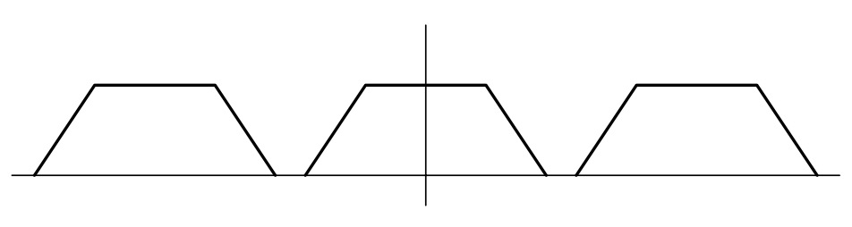

Figure 3 $f>2W$: non-overlapping spectrum

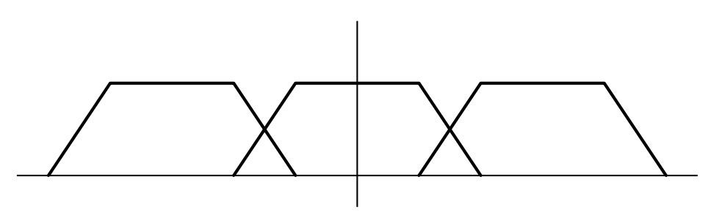

Figure 4 $f>2W$: overlapping spectrum

When the symbol rate *f* is less than the Nyquist rate, we can find a ISI-free pulse in this condition. The most famous ISI-free spectrum is drawn in figure 5 and 6 in domain of frequency and time. The name of this spectrum is raised-cosine spectrum, expressed in equation 3.6.

$$X\left(f\right)=\left\{\begin{aligned}T for 0≤\left|f\right|≤\frac{1-α}{2T} \\ \frac{T}{2}[1+\cos{\frac{πT}{α}(\left|f\right|-\frac{1-α}{2T})]} for \frac{1-α}{2T}≤\left|f\right|≤\frac{1+α}{2T} \\ 0 for \left|f\right|≥\frac{1-α}{2T}\end{aligned}\right.$$

$$roll-off factor : α (0≤α≤1)$$

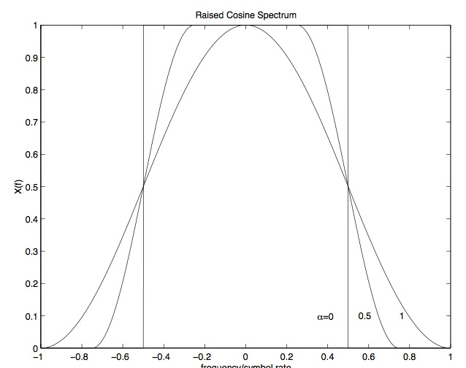

Figure 5 Raised-cosine spectrum in frequency domain

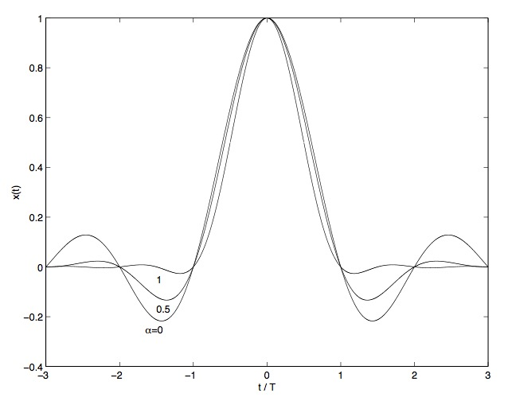

Figure 6 Raised-cosine spectrum in time domain

# Equalization

For many physical channels, the signals transmitted this channel get distorted and also they are not bandlimited (in practice, there are time limited signals). These channels can be represented by an LTI filter and AWGN source is affecting at the end of the LTI filter as you can check in figure 7. We call this type of channel as a dispersive channel.

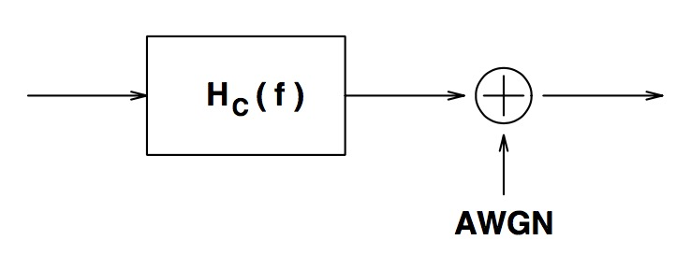

Figure 7 Dispersive channel model

In general, if the signal does not satisfy Nyquist condition, ISI will exist. We can describe a whole system for communication system having a linear modulation through a dispersive channel as shown in figure 8. {*Ik*} is the sequence of information symbols. *HT(f), HC(f)* and *HR(f)* are the transfer function of the transmission filter, the dispersive channel filter and the receiving filter. With these communication system, we can represent the Nyquist condition for no ISI as following:

$$X\left(f\right)= H_{T}\left(f\right)H_{C}\left(f\right)H_{R}\left(f\right) (4.1)$$

$$T= \sum_{n=-∞}^{∞}{X\left(f-\frac{n}{T}\right) (4.2)}$$

We can set up the receiving filter to be the matched filter, i.e., set $H_{R}\left(f\right)=H_{T}^{*}(f)H_{C}^{*}(f)$, and choose the transmission filter which is satisfying expression 4.2. But this strategy has a disadvantage. In real situation, it is difficult to build the proper filters for *HT(f)* and *HR(f)*. Also, to build the transmission and receiving filters, we must have an information of the channel response *HC(f)* in advance, which is a rare case in practical situations. The another method is to fix the transmission filter and choose the receiving filter *HR(f)* to satisfy the Nyquist condition. Also this method is hard since it is difficult to build proper filter *HR(f)* to remove ISI. But what we want in the end are the samples at interval *T* at the receiver side. So there is a possibility of choosing more simple and practical filter *HR(f)* and put a digital filter, named *equalizer*, behind of it. The purpose of this digital filter is to remove ISI. This is how we remove ore minimize ISI effect on the signal and the method is named as *equalization.*  Since the digital filter can be modified easily, we can use this method for different equalization schemes [2].

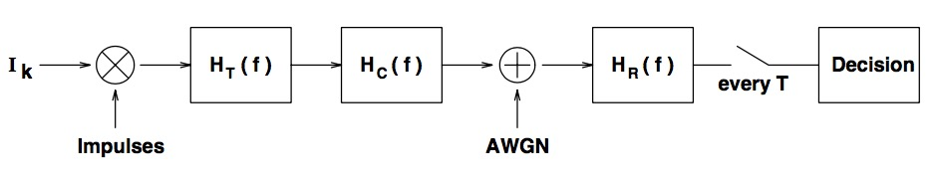

Figure 8 Dispersive channel model (Continuous-time)

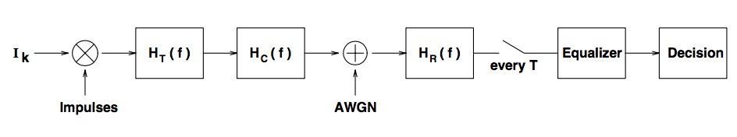

Figure 9 Communication system with equalizer

# equivalent disvrete-time model

Now we are going to convert continuous-time communication system model in figure 9. to an equivalent discrete-time model to make it easier to work with it. Following are steps of the translation procedure:

* we input symbol to the communication system every T seconds and receive the output with same rate. Since $H_{T}(f)$*, $H_{C}(f)$*  and $H_{R}(f)$ are LTI filters, they can be merged into a single digital LTI filter, which is equivalent. Let’s denote this filter *H(z)* and $\left\{h_{k}\right\} (-∞<k<∞)$ is impulse response of the filter. And we can compute the output, denoted by $I_{k}^{'}$ of the discrete time-linear filter model, shown in figure 10.

$$I_{k}^{'}=\sum_{j}{I_{j}h_{k-j}+n_{k}} \\ = I_{k}h_{0}+ \sum_{j≠k}{I_{j}h_{k-j}+n_{k} (4.1)}$$

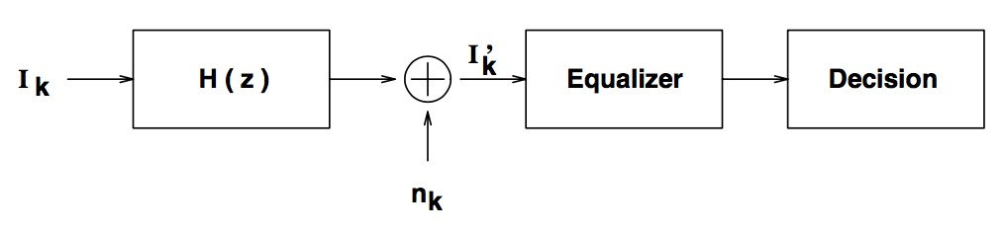

Figure Equivalent dispersive channel model (discrete-time)

* Commonly, the equalizer has two parts. One is *noise-whitening* digital filter *HW(f)* and the other one is equalizing circuit. Let assume *G(z) = H(z)HW(z)* and we can convert figure 12 to figure 13 and represent the output sequence ${\tilde{I}}_{k}$ as following:

$${\tilde{I}}_{k}=\sum_{j}{I_{j}g_{k-j}+n_{k}} \\ = I_{k}g_{0}+ \sum_{j≠k}{I_{j}g+n_{k} (4.2)}$$

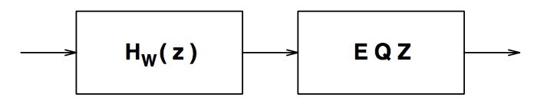

Figure Typical equalizer

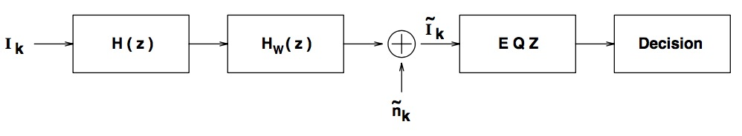

Figure Communication system model (discrete-time)

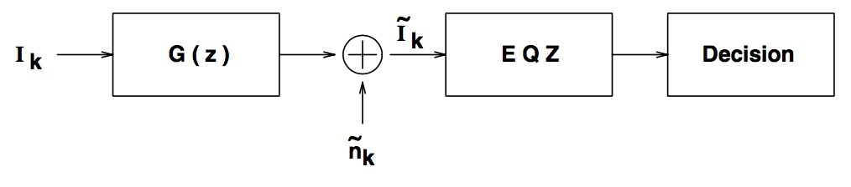

Figure White-noise linear filter model (discrete-time)

* Finally, equalizing circuit (EQZ) suppress or eliminate intersymbol interference factors from the output of $G(z)$. Assuming the equalizing circuit is also a LTI filter with transfer function *HE(z),* then the output of the equalizing circuit will be presented as:

$${\hat{I}}_{k}=\sum_{j}{{\tilde{I}}_{k-j}h_{E,j} } (4.3)$$

$$impulse reponse of H_{E}\left(z\right)= h_{E } (4.4)$$

# Zero-forcing equalizer

Let’s take a close look on the equalizer, which is also linear, we mentioned in previous section, i.e. build with LTI filter with *HE(z)* filter as the equalizing filter. The easiest way to eliminate the ISI is to take the equalizing filter so that the output of the equaliz-er give back information with no noise, i.e. ${\hat{I}}_{k}=I_{k}$ for all *k*. This condition can be obtained by selecting the transfer function $H\left(z\right)=\frac{1}{G\left(z\right)}.$ This procedure is named as *zero-forcing* equalization. ISI component at the equalizer output is forced to zero in this method.

This strategy will work properly if there is no noise. But in reality, there are noises. The noise can effect on the performance of this system, i.e. it is true that the ISI component is forced to zero. But on the other sides, there may be a chance that the equalizing filter will enhancing the noise power. This can result in degrading the error performance. To check this phenomena, we will derive noise-to-signal at the output of the zero-forcing equalizer when the *HT(f)* is fixed and matched filter is set in receiving side, i.e.,

$$H_{R}\left(f\right)=H_{T}^{*}\left(f\right)H_{C}^{*}\left(f\right). (5.1)$$

In this case, *H(z)* is derived as following:

$$H\left(e^{j2πfT}\right)=\frac{1}{T}\sum_{n=-∞}^{∞}{{\left|H_{T}(f-\frac{n}{T})H_{C}(f-\frac{n}{T})\right|}^{2} } (5.2)$$

And the noise-whitening filter *HW(f)* can be taken as

$$H_{W}\left(e^{j2πfT}\right)=\frac{1}{\sqrt{H\left(e^{j2πfT}\right)} } (5.3)$$

and the overall digital filter *G(z)* is

$$G\left(e^{j2πfT}\right)=H_{W}\left(e^{j2πfT}\right)H_{W}\left(e^{j2πfT}\right) \\ = H_{W}\left(e^{j2πfT}\right) (5.4)$$

Now we can have the zero-forcing equalizer filter *HE(z)* as

$$H_{E}\left(e^{j2πfT}\right)=\frac{1}{G\left(e^{j2πfT}\right)} \\ =\frac{1}{\sqrt{H\left(e^{j2πfT}\right)} }. (5.5)$$

Let’s input independent and identically distributed random variable with zero mean and unit variance into the system. The signal energy at the output of the equalizer will be $\int_{–T/2}^{T/2}{df}=1/T$. On the other hand, the PSD of the noise part at the output equalizer is $\frac{N_{0}}{2}{\left|H_{E}(e^{j2πfT})\right|}^{2}.$ Then we can get the noise energy at the output of equalizing filter as $\int_{–T/2}^{T/2}{\frac{N_{0}}{2}{\left|H_{E}(e^{j2πfT})\right|}^{2}}df$. With these results, we can compute the SNR as following:

$$SNR \\ ={\left\{\frac{N_{0}T^{2}}{2}\int_{-\frac{T}{2}}^{\frac{T}{2}}{{\left[\sum_{n=-∞}^{∞}{{\left|H_{T}\left(f-\frac{n}{T}\right)H_{C}\left(f-\frac{n}{T}\right)\right|}^{2}}\right]}^{-1}df}\right\}}^{-1} \\ (5.6)$$

We can check that the SNR expression has the folded spectrum of the signal component at the input of the receiver as a parameter which implies that SNR is dependence on the folded spectrum. In other words, it results to very poor SNR, if there is a certain region in the folded spectrum with small magnitude.

References

1. B P Lathi and Z Ding, *Modern Digital and Analog Communication Systems*, 4th ed, UK:Oxford University Press, 2010 .
2. Wong & Lok, *Theory of Digital Communication*